Bug#1

1. The line(s) containing each bug:

1. The corrected version of the line(s):



1. What was wrong with the line(s) and how you fixed it:

This place has a logical error that checking the result, but it is always to be true. This could be a problem that we should not use I as out result.

1. The debugger tool or technique you used to recognize and find the bug:

I placed logging statements to log the returning result. That I knew the result would be always to be i, which is not we expect.

Bug#2

1. The line(s) containing each bug:

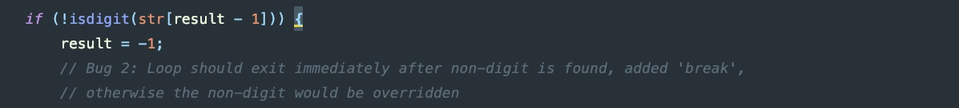

1. The corrected version of the line(s):



1. What was wrong with the line(s) and how you fixed it:

This place should exit immediately if they find any character is not a dig. If it doesn’t exit, then the next iteration would override the non-digit value. Therefore, I added an break to exit this loop immediately.

1. The debugger tool or technique you used to recognize and find the bug:

I added a logging statement to check the returning result of this function. I knew that this function couldn’t properly find the value is number or not.

Bug#3

1. The line(s) containing each bug:



1. The corrected version of the line(s):

None. Just removed.

1. What was wrong with the line(s) and how you fixed it:

The code doesn’t affect the application, but it is just a redundant declaration. I just removed it.

1. The debugger tool or technique you used to recognize and find the bug:

The IDE code analyzer gave me hint that I have an unused variables that I can remove.

Bug#4

1. The line(s) containing each bug:

1. The corrected version of the line(s):



1. What was wrong with the line(s) and how you fixed it:

This place doesn’t correctly check the line with new line symbol but null terminator. I changed the condition to check if the position holding the character value is new line symbol.

1. The debugger tool or technique you used to recognize and find the bug:

I added a logging statement in this if-block, but it didn’t print out any indexing line position. Therefore, I knew the if-condition cannot correctly work.

Bug#5

1. The line(s) containing each bug:



1. The corrected version of the line(s):



1. What was wrong with the line(s) and how you fixed it:

The str[i] could be a null terminator. If there is no any handling for this situation. It will cause the array indexing afterwards access the wrong position of that array, so I added an if statement to check that situation.

1. The debugger tool or technique you used to recognize and find the bug:

I find out this bug with my observation.

Bug#6

1. The line(s) containing each bug:



1. The corrected version of the line(s):



1. What was wrong with the line(s) and how you fixed it:

The isNumber function returns a -1 value to indicate that the given word is not a number. This place checks it with non-zero value. That is not correct, so I changed it to check if it is negative one.

1. The debugger tool or technique you used to recognize and find the bug:

I find out this bug with my observation.

Bug#7

1. The line(s) containing each bug:



1. The corrected version of the line(s):



1. What was wrong with the line(s) and how you fixed it:

This result from nextWhite function could be -1, but this place doesn’t check that. I added an if-statement to find out that, and changed sp value into the length of the given word.

1. The debugger tool or technique you used to recognize and find the bug:

I added a logging statement after the line calling nextWhite to see what the value is.

Bug#8

1. The line(s) containing each bug:



1. The corrected version of the line(s):

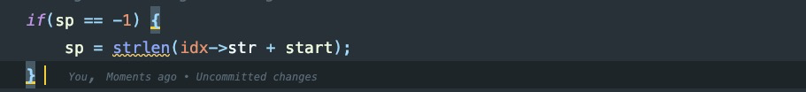

1. What was wrong with the line(s) and how you fixed it:

This result from nextWhite function could be -1, but this place doesn’t check that. I added an if-statement to find out that, and changed sp value into the length of the given word.

1. The debugger tool or technique you used to recognize and find the bug:

I added a logging statement after the line calling nextWhite to see what the value is.